Mozambique

## Respect for rule of law (ROL) data

The data set shows the data on the respect of the rule of law for the country.

## # A tibble: 19 x 5  
## country iso3c date ruleOfLaw ruleOfLawCategory4   
## <chr> <chr> <dbl> <dbl> <chr>   
## 1 Mozambique MOZ 1996 -0.806 ROL moderately disrespected  
## 2 Mozambique MOZ 1998 -0.799 ROL moderately disrespected  
## 3 Mozambique MOZ 2000 -0.727 ROL moderately disrespected  
## 4 Mozambique MOZ 2002 -0.640 ROL moderately disrespected  
## 5 Mozambique MOZ 2003 -0.673 ROL moderately disrespected  
## 6 Mozambique MOZ 2004 -0.670 ROL moderately disrespected  
## 7 Mozambique MOZ 2005 -0.617 ROL moderately disrespected  
## 8 Mozambique MOZ 2006 -0.612 ROL moderately disrespected  
## 9 Mozambique MOZ 2007 -0.598 ROL moderately disrespected  
## 10 Mozambique MOZ 2008 -0.607 ROL moderately disrespected  
## 11 Mozambique MOZ 2009 -0.591 ROL moderately disrespected  
## 12 Mozambique MOZ 2010 -0.472 ROL moderately disrespected  
## 13 Mozambique MOZ 2011 -0.567 ROL moderately disrespected  
## 14 Mozambique MOZ 2012 -0.586 ROL moderately disrespected  
## 15 Mozambique MOZ 2013 -0.816 ROL moderately disrespected  
## 16 Mozambique MOZ 2014 -0.810 ROL moderately disrespected  
## 17 Mozambique MOZ 2015 -0.849 ROL moderately disrespected  
## 18 Mozambique MOZ 2016 -1.05 ROL highly disrespected   
## 19 Mozambique MOZ 2017 -1.01 ROL highly disrespected

## Respect for rule of law (ROL) trend

The plot shows the trend of the respect for the rule of law for the country.

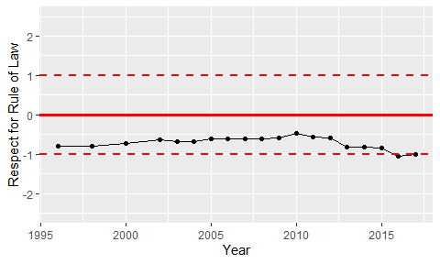

Trend of the Respect for the Rule of Law